**Import / Export feature**

* **Entity / Equipment Templates**

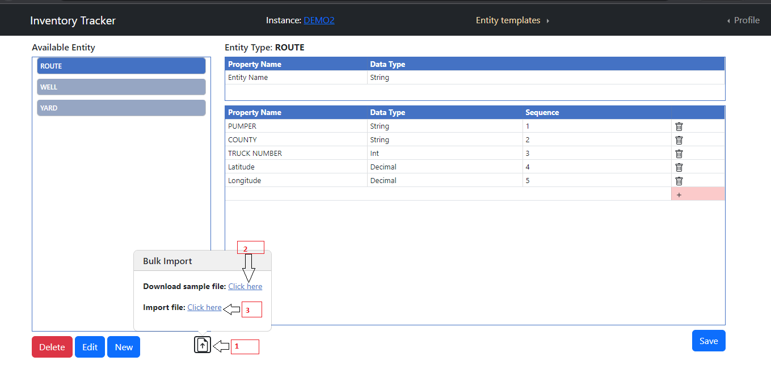

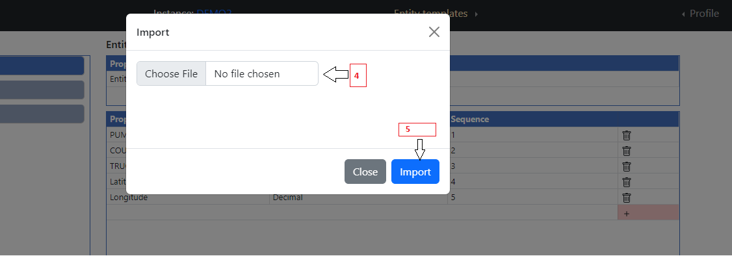

1. Click on Import file button.
2. If you don’t have any idea about which file formats we accept for import then click on Download sample File Click here button else skip step 2.
3. Click on Import File Click here button.
4. Upload file.
5. Click on Import button.

* **Entity / Equipment Search -> New Entity Import**

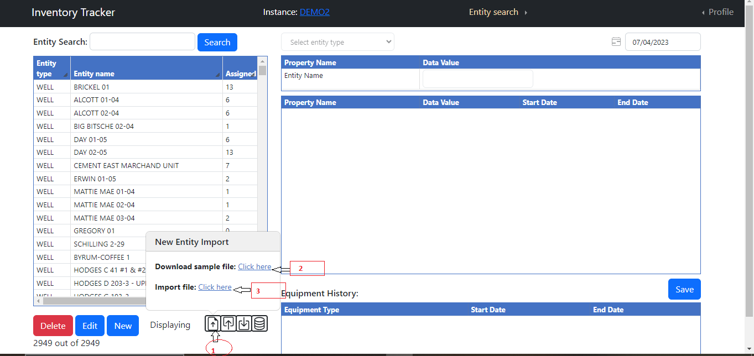



1. Click on Import file button.
2. If you don’t have any idea about which file formats we accept for import then click on Download sample File Click here button else skip step 2.
3. Click on Import File Click here button.
4. Upload file.
5. Click on Import button.

* **Entity / Equipment Search -> Export**

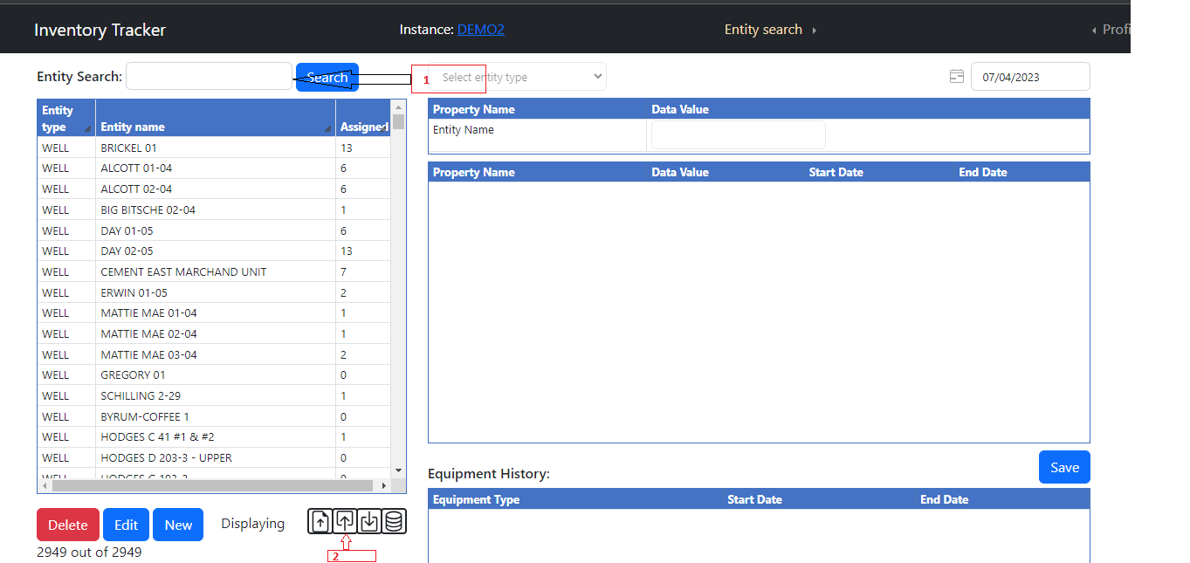

1. If you want export based on search then first search else skip this step.
2. Click on export button.

* **Entity / Equipment Search -> Import**

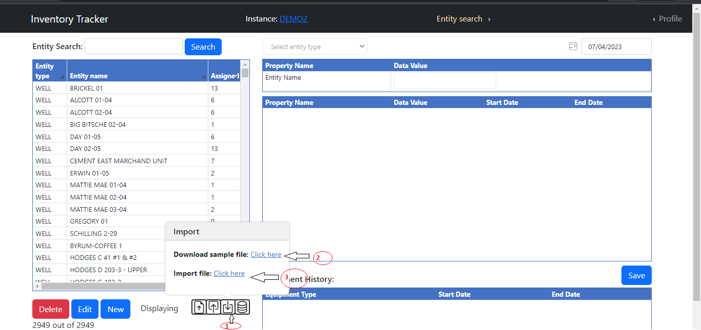



1. Click on Import file button.
2. If you don’t have any idea about which file formats we accept for import then click on Download sample File Click here button else skip step 2.
3. Click on Import File Click here button.
4. Upload file.
5. Click on Import button.

* **Equipment-Entity / Entity-Equipment Assignment -> Import Date Range**

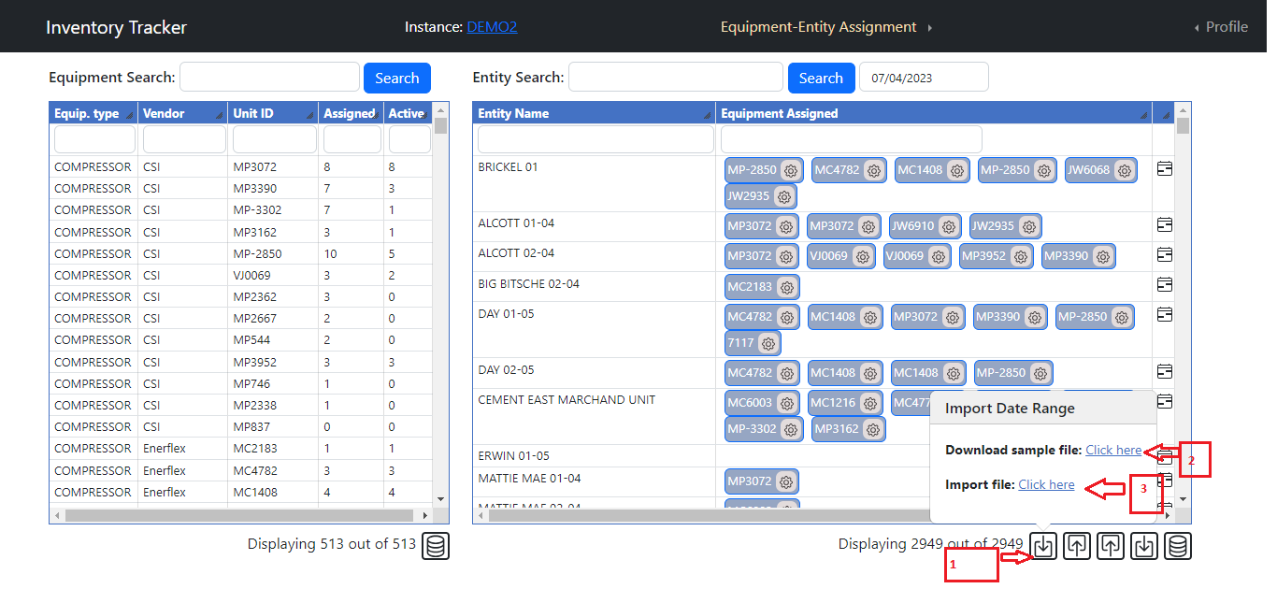

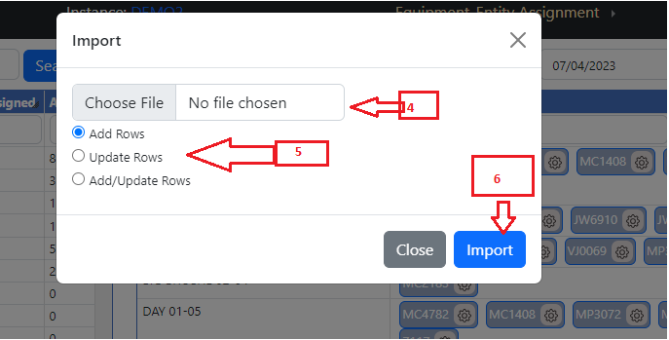

1. Click on Import Date Range button.
2. If you don’t have any idea about which file formats we accept for import then click on Download sample File Click here button else skip step 2.
3. Click on Import File Click here button.
4. Upload file.
5. Select which operation you need to perform. Default is Add Rows.

Add Row – It Add row into database table which is new.

Update Row – It update records into database table which matches.

Add/Update Rows - Combination of Add Row and Update row.

1. Click on Import button.

* **Equipment-Entity / Entity-Equipment Assignment -> Export Date Range**

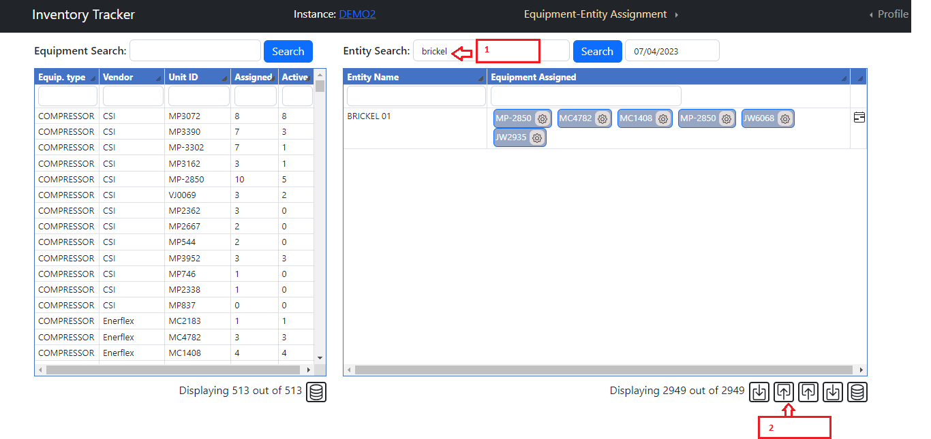

1. If you want export based on search then first search else skip this step.
2. Click on export date range button.

* **Equipment-Entity / Entity-Equipment Assignment -> Export**

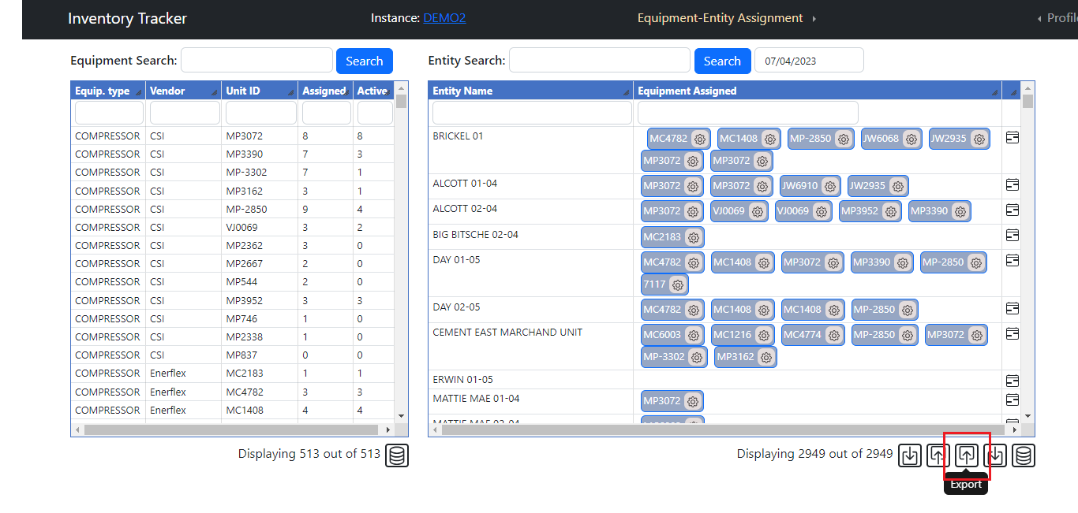

1. If you want export based on search then first search else skip this step.
2. Click on export button.

* **Equipment-Entity / Entity-Equipment Assignment -> Import**

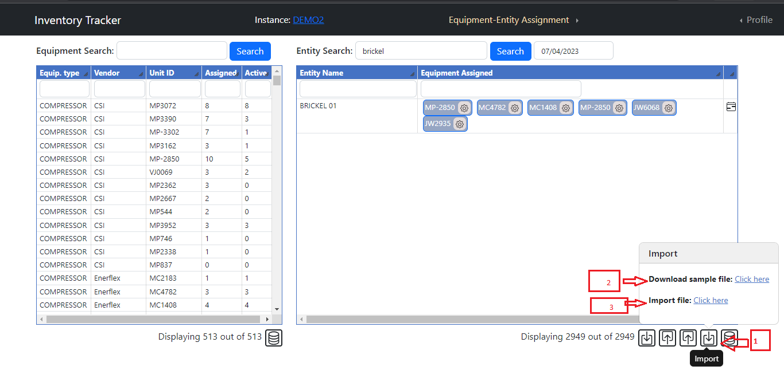



1. Click on Import file button.
2. If you don’t have any idea about which file formats we accept for import then click on Download sample File Click here button else skip step 2.
3. Click on Import File Click here button.
4. Upload file.
5. Click on Import button.

**Add / Edit feature**

* **Add New Equipment / Entity**

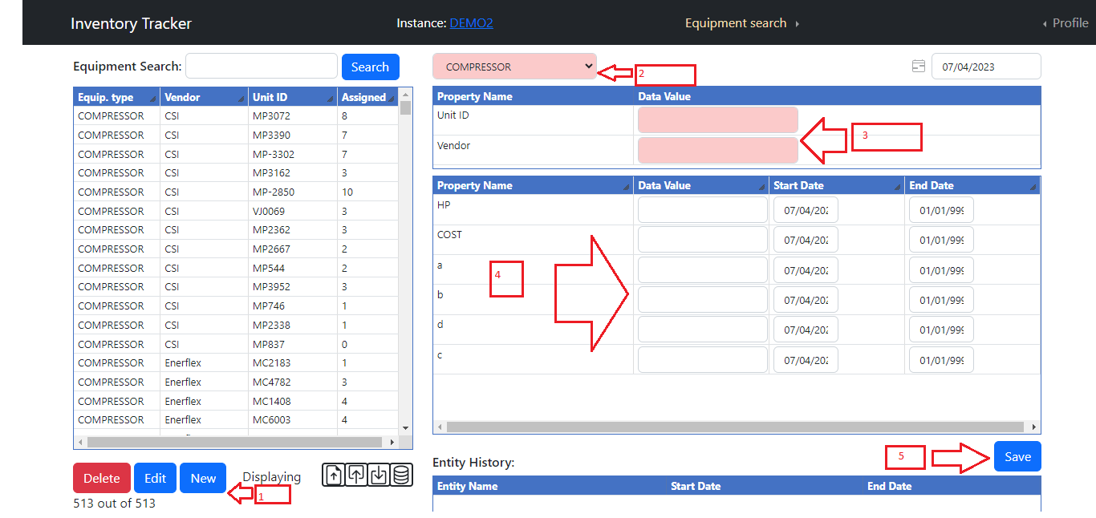

1. Click on New button.
2. Select Equipment type from dropdown list. (Required)
3. Enter Unit ID and Vendor which is required fields. . (Required)
4. Enter Data into text box and change date if you want to change it. (Optional)
5. Click on Save button.

* **Edit Equipment /Entity**

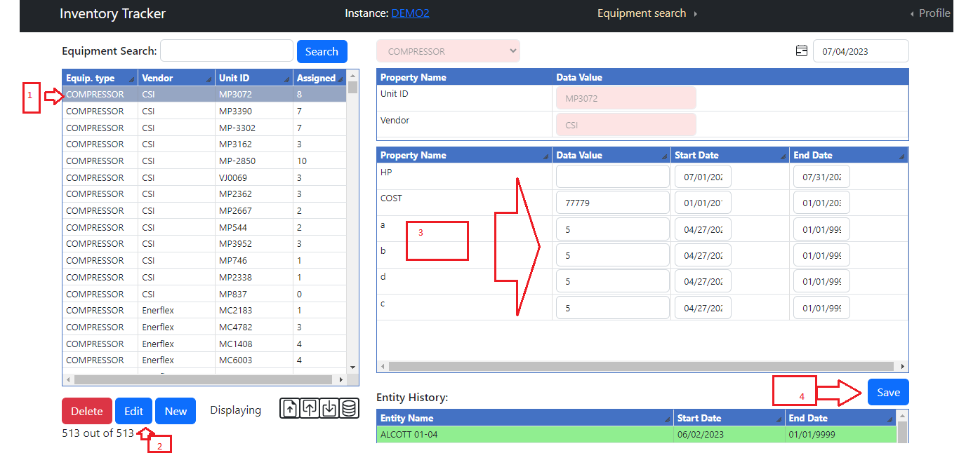

1. Select any equipment which you need to edit.
2. Click on edit button.
3. Change Data value or start / end dates (Optional).
4. Click on save button.

**Equipment – Entity /Entity- Equipment Assignment**

* **Equipment and Entity search**

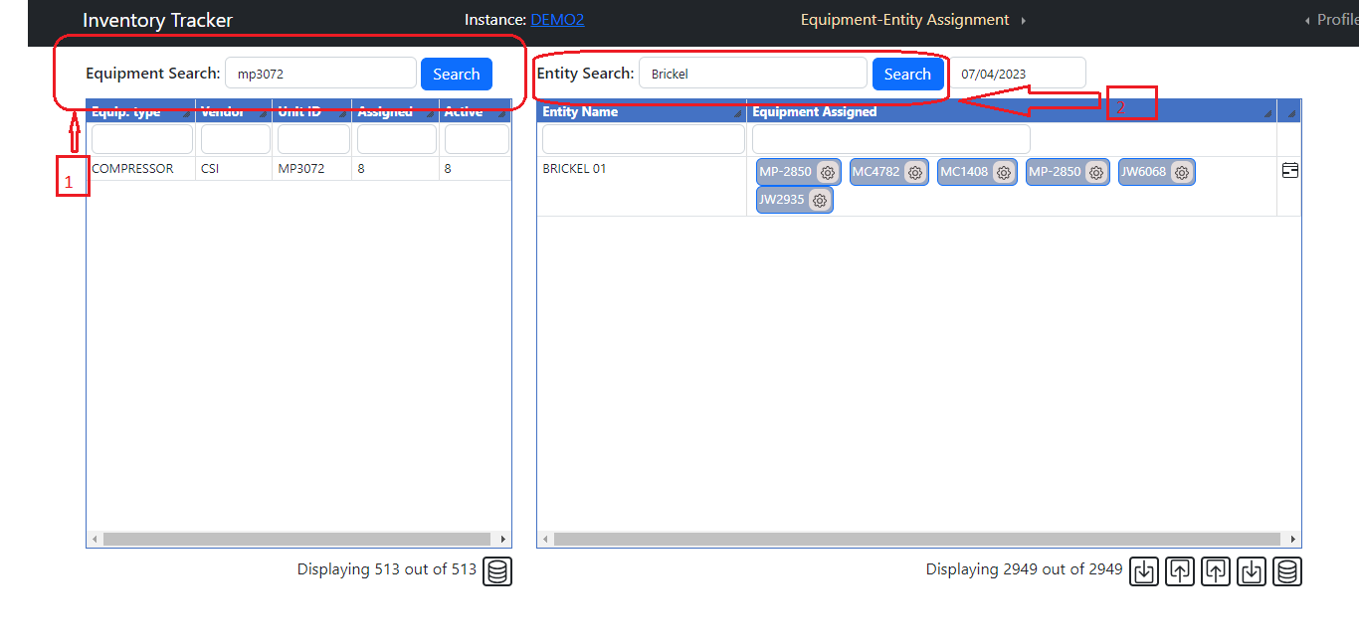

1. Type text on Equipment / Entity search text box then click on Search button or press Enter key it will filter data and display in respective tables.

* **Date functionality**

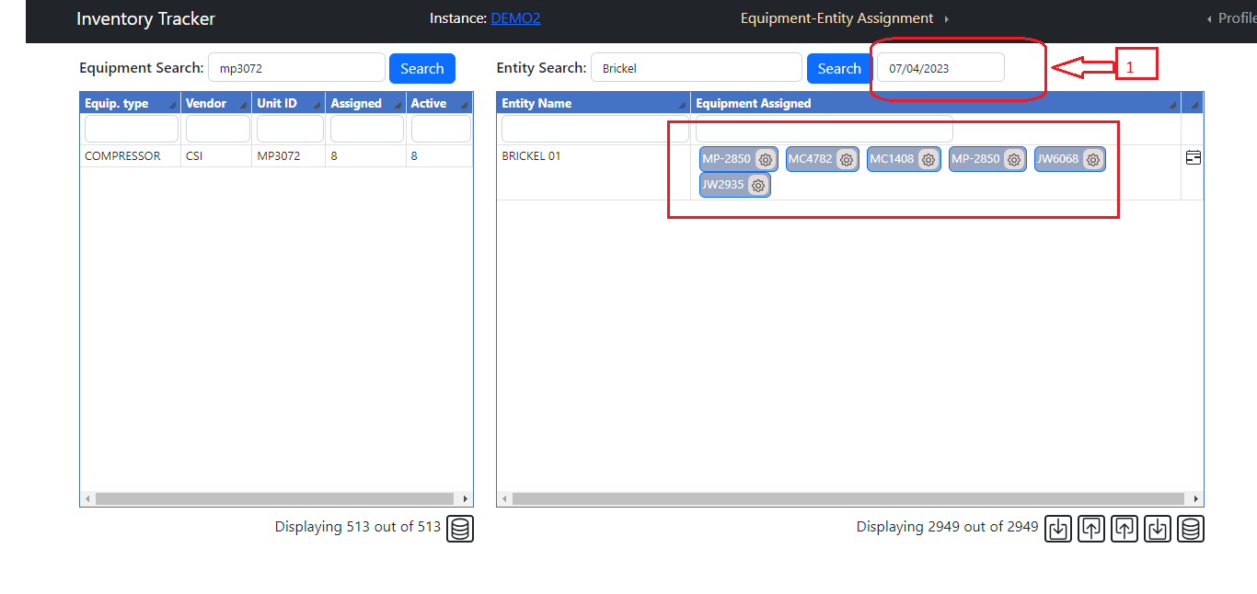

1. Based on this date all assignment data are filter and display in Equipment Assignment Table.

* **Search functionality in tables**

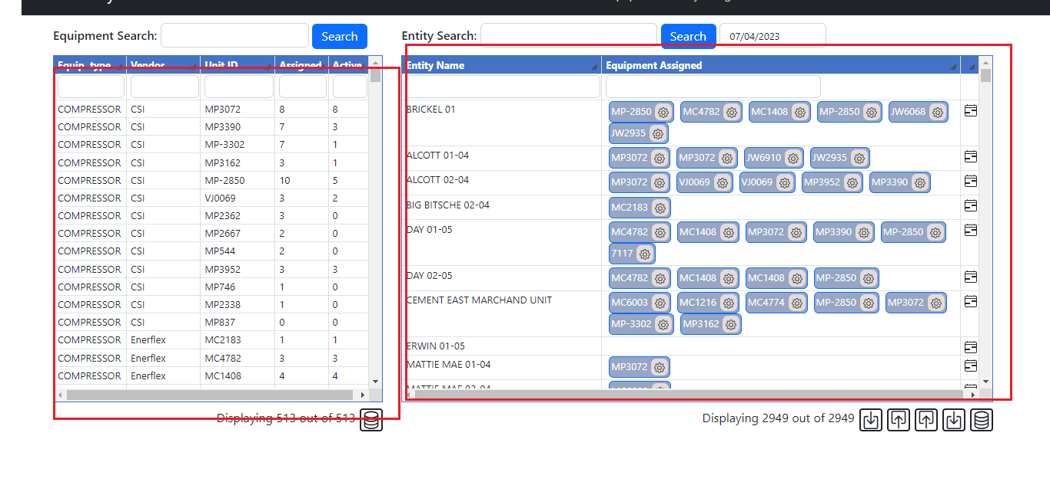

1. In this both tables we display data from Equipment and Entity records in Equipment and Entity tables respective.
2. Both table contain text box in first row for search into respective tables.

* **Column chooser in tables**

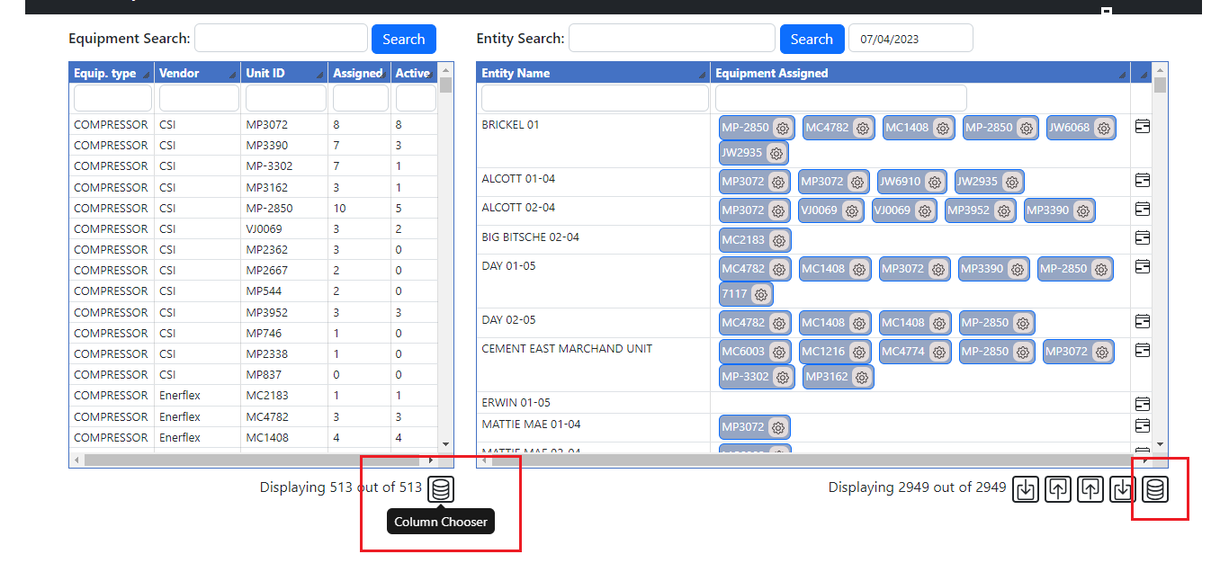

1. Click on this column chooser it will open below popup for add column into respective table.

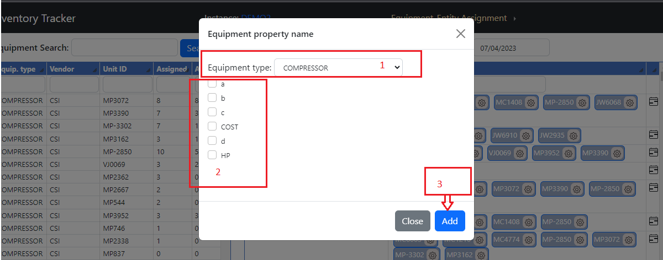

1. Select Equipment type then select property name and click on add button. It will add property name columns into table.

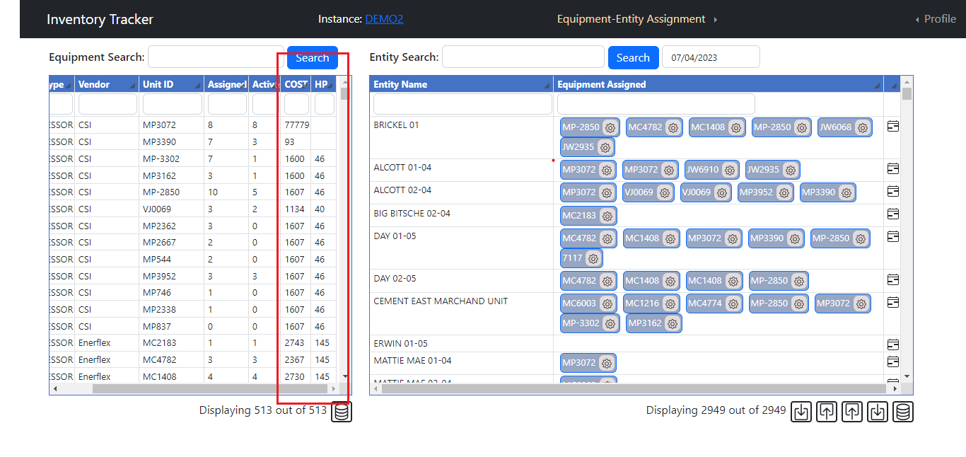

1. All columns are sortable and resizable.

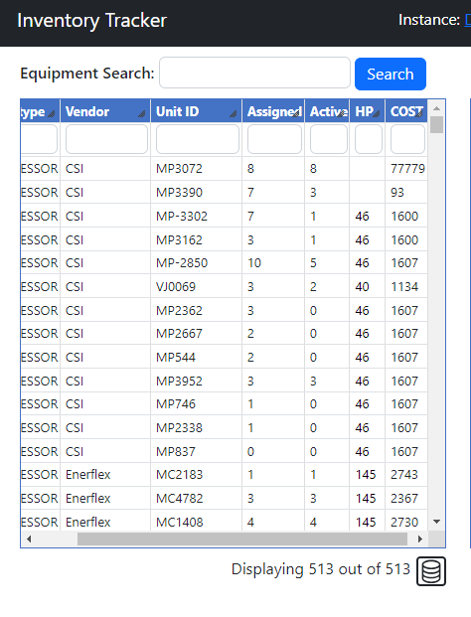

* **Calendar Control**

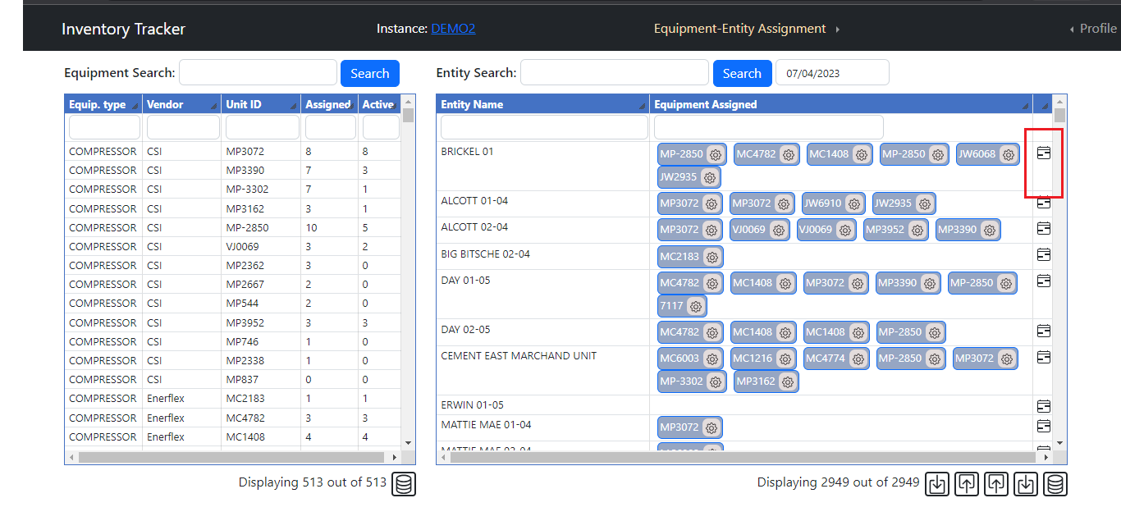

1. Click on this calendar control it will open below screen.

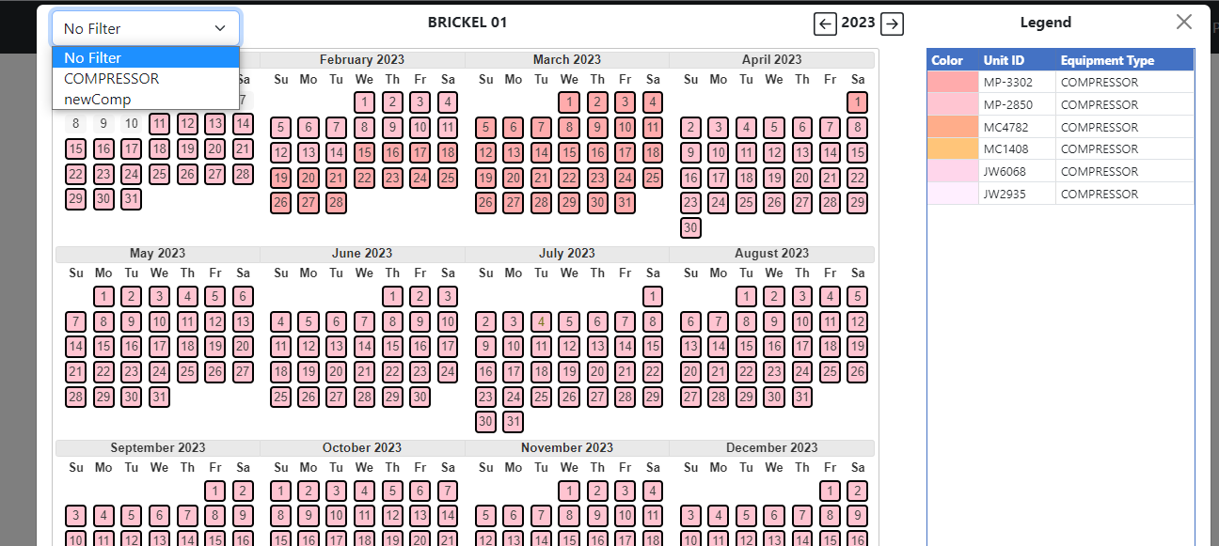

1. It will display all equipment type which is assigned for date range. No filter then it display all equipment type. If we filter it then based on it equipment type displayed.

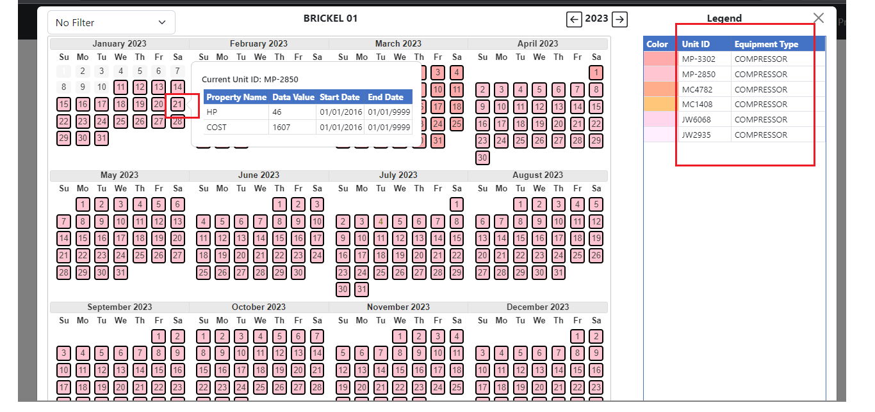

1. If we click on calendar date or any equipment type then it open below popup for add / update or remove date range.

For Update Date range of Unit ID

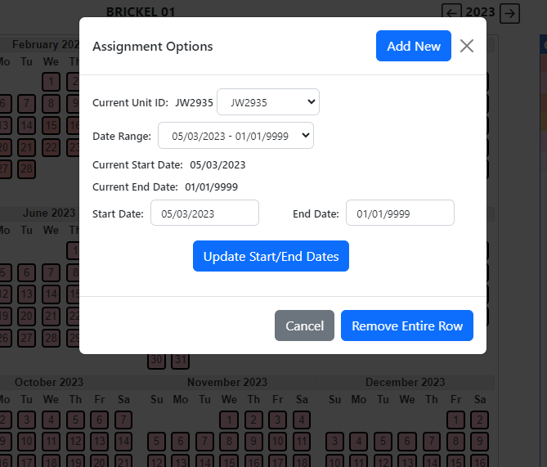

* Change Start / End date or both and click on Update Start / End date for update it.
* Click on Remove entire row for remove selected row.
* Change Unit Id drop down for select other unit id.

1. For Add Date range

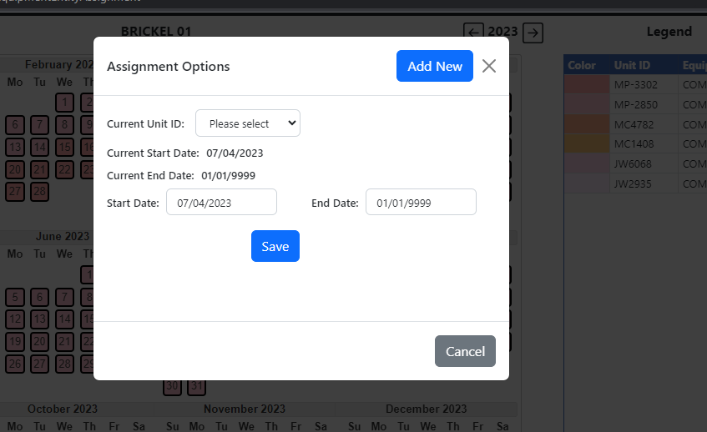

1. Select Unit Id and enter start and end date then save it.

* **Color functionality**

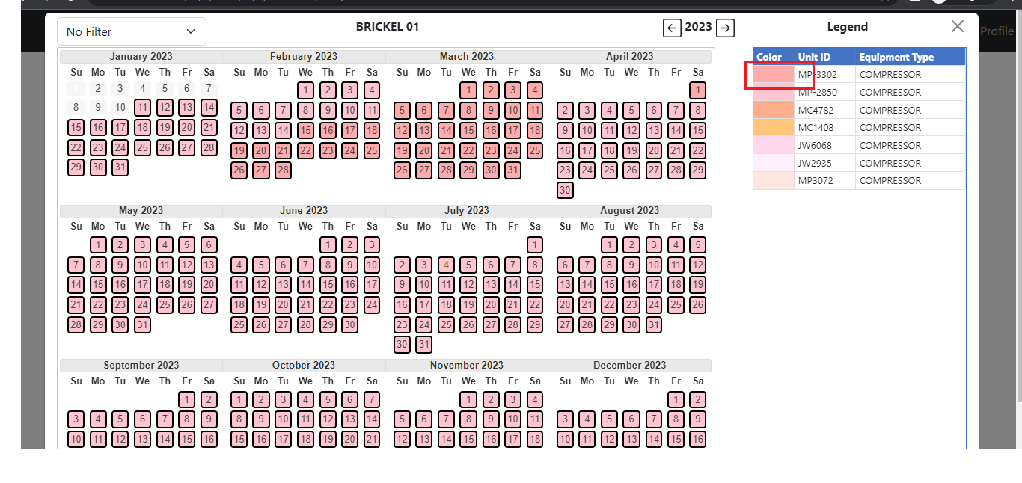

1. Click on this color it will open below popup for change color.

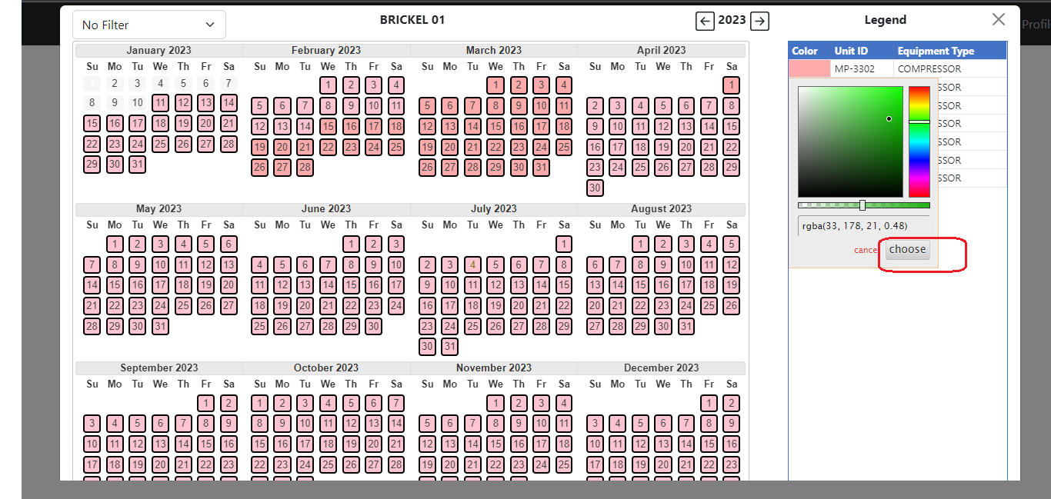

1. Select color and click on choose button. It will change color of selected Unit Id into calendar control.

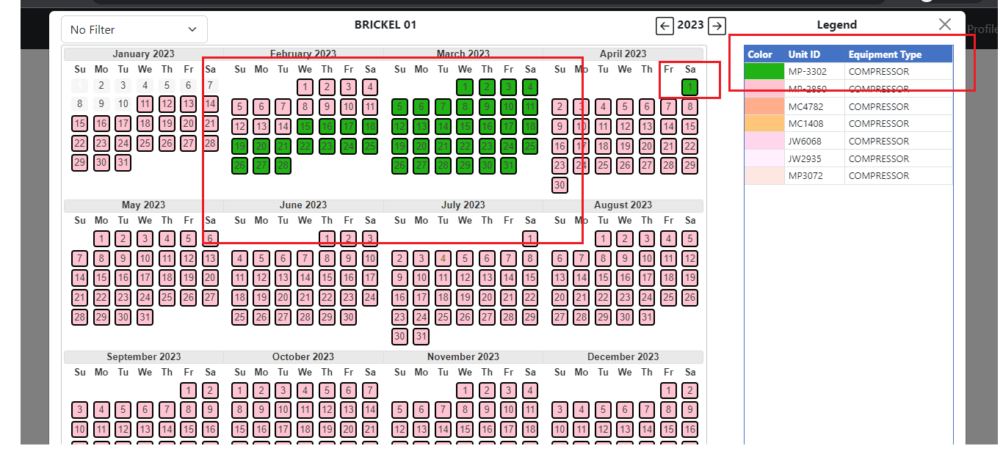

* **Assignment Options**

1. Click on gear icon it will open popup for update start / end date or remove entire row.

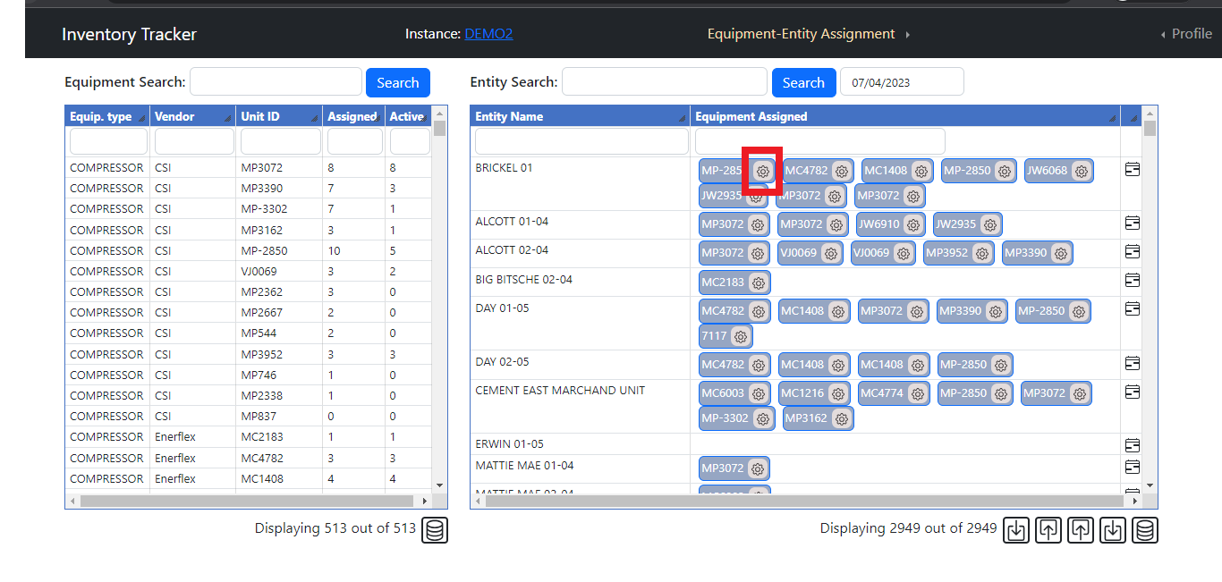

* Change start date or end date or both then click on Update Start/End Dates it will update it for selected Unit ID. (1)
* If you need to remove specific Date range for selected table then click on remove entire row it will remove it.(2)

